NATIONAL UNIVERSITY OF MODERN LANGUAGE ISLAMABAD
Lab 09


Submitted to:
Ms. Fatima Gillani
Submitted by:
Zulqarnain Hassan
Roll No: …………………… SP21379
Subject: …………………… SCD
Department: ……………… BSSE-5-Afternoon
Date: ……………………… 04-12-2024

Tasks: 01
package lab_6;

import java.util.Scanner;

class Rectangle{
double lenght;
double width;
String rectangleName;

Rectangle(double length,double width,String rectangleName){
this.lenght=length;
this.width=width;
this.rectangleName=rectangleName;

}

void showArea(double length,double width, String rectangleName){
System.out.println(rectangleName+ " :");
System.out.println("area :"+ length*width);

}
void showPerimeter(double length,double width, String rectangleName){
System.out.println(rectangleName+ " :");
System.out.println("perimeter :"+ 2*(length+width));

}

}
public class labtask09 {

public static void main(String[] args) {
Scanner sc =new Scanner(System.in);
System.out.println("enter rectangle name: ");
String name=sc.next();
System.out.println("enter length of rectangle: ");
double length=sc.nextDouble();
System.out.println("enter width of rectangle: ");
double width=sc.nextDouble();

Rectangle rectangle1=new Rectangle(length, width, name);

rectangle1.showArea(rectangle1.lenght,rectangle1.width,rectangle1.rectangleName);

rectangle1.showPerimeter(rectangle1.lenght,rectangle1.width,rectangle1.rectangleName);

}

}

Output
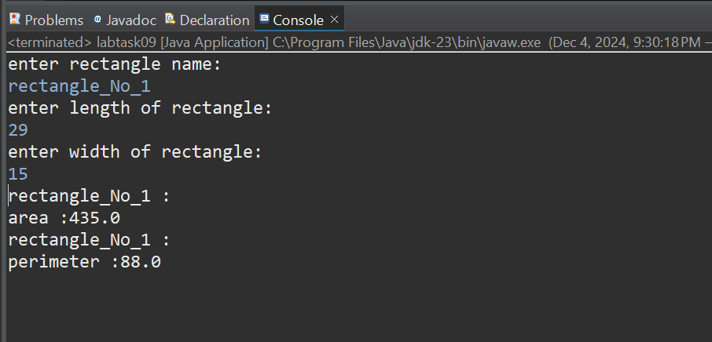

Task 02
package lab_6;

class Employee{
private String name;
private int employeeId;
private String department;
private String position;
private double salary;

Employee(String name, int employeeId, String department, String position, double salary) {
this.name = name;
this.employeeId = employeeId;
this.department = department;
this.position = position;
this.salary = salary;
}

public String getName() {
return name;
}
public void setName(String name) {
this.name = name;
}

public int getEmployeeId() {
return employeeId;
}
public void setEmployeeId(int employeeId) {
this.employeeId = employeeId;
}

public String getDepartment() {
return department;
}
public void setDepartment(String department) {
this.department = department;
}

public String getPosition() {
return position;
}
public void setPosition(String position) {
this.position = position;
}

public double getSalary() {
return salary;
}
public void setSalary(double salary) {
this.salary = salary;
}
}

class Payroll{

double calculatePayroll(Employee employee) {
return 5000.0;
}

void updateSalary(Employee employee, double newSalary) {
employee.setSalary(newSalary);
}

void increaseSalary(Employee employee, double percentage) {
double currentSalary = employee.getSalary();
double increaseAmount = currentSalary * (percentage / 100);
employee.setSalary(currentSalary + increaseAmount);
}

void decreaseSalary(Employee employee, double percentage) {
double currentSalary = employee.getSalary();
double decreaseAmount = currentSalary * (percentage / 100);
employee.setSalary(currentSalary - decreaseAmount);
}
}

public class Labtask09_2 {
public static void main(String[] args) {

Employee employee1=new Employee("ali", 1, "designing", "designer", 30000.0);

System.out.println("name: "+employee1.getName());
System.out.println("salary: "+employee1.getSalary());
System.out.println("position: "+employee1.getPosition());
System.out.println("department: "+employee1.getDepartment());

Payroll p1=new Payroll();
p1.updateSalary(employee1, 50000);
p1.decreaseSalary(employee1, 200);
p1.increaseSalary(employee1,5000);
System.out.println("calculatePayroll: "+p1.calculatePayroll(employee1) );

}
}

Output
